Colonial and Settler-Colonial Discourse in 1939: An NLP Analysis of People, Land, and Culture in India, British Malaya, and Australia

Kulkarni, Anish Sanjay
Department of Computer Science and Engineering
University of New South Wales
Sydney
kulkarni.ask.anan16@gmail.com

Abstract—Historical newspapers provide a useful source for examining how people, communities, land, and culture were represented during periods of political and social change. This study investigates English-language newspaper discourse in India, British Malaya, and Australia during 1939, a significant year in the wider history of the British Empire and the year in which the Second World War began. A corpus of 36 newspaper articles was constructed from digitised newspaper archives and manually classified according to three themes: People, Land, and Culture. The texts were conservatively preprocessed to address common OCR and formatting issues while preserving historical terminology. Several NLP techniques were then applied, including normalised word-frequency analysis, article-level term frequency-inverse document frequency (TF-IDF), collocation analysis, and concordance analysis. The results show differences in the vocabulary and contextual patterns of the three corpora. The Indian articles were more strongly associated with political and institutional vocabulary, the British Malayan articles showed greater emphasis on ethnic communities, labour, and colonial policy, while the Australian articles were strongly associated with Aboriginal identity, government administration, reserves, and racial boundaries. Contextual analysis further showed that terms such as “government” and “native” were used in different ways across the selected articles. The findings demonstrate how NLP can support historical analysis by identifying recurring linguistic patterns while retaining the importance of manual interpretation and historical context. Given the small and purposively selected corpus, the results are exploratory rather than representative of newspaper discourse as a whole.
Keywords—Historical newspapers, natural language processing, colonial discourse, settler colonialism, computational humanities, OCR, discourse analysis, British Empire, Australia, British Malaya, India.

Introduction

Newspapers are an important source for understanding how people and communities were described during periods of political and social change. They do not simply record historical events, but also reflect the language and viewpoints used to discuss different groups, government policies, land, and cultural practices. This makes newspapers a useful source for examining how colonial and settler-colonial societies represented the people around them.
The year 1939 provides an interesting point of comparison because it was a period of significant political change and growing international tension. India and British Malaya[3], [4] were still under British colonial rule, while Australia was a self-governing settler-colonial society in which Aboriginal people continued to experience racial discrimination and government control[1], [2]. It was also the year in which the Second World War began, adding a wider context of imperial politics, national identity, and changing relationships between different communities.
This study examines English-language newspaper articles published in 1939 in India, British Malaya, and Australia using natural language processing (NLP). The analysis focuses on three themes: People, referring to the representation of individuals and communities; Land, referring to topics such as territory, settlement, agriculture, and land ownership; and Culture, referring to customs, religion, education, traditions, and other cultural practices. These themes were selected to provide a consistent basis for comparing the types of issues discussed across the three contexts.
The main research question is: How did English-language newspaper discourse differ in its representation of people, land, and culture across India, British Malaya, and Australia in 1939, and what common linguistic patterns can be identified using NLP?
To investigate this question, a corpus of 36 newspaper articles was constructed and manually classified according to the three themes. The texts were then cleaned and tokenized before applying several NLP techniques, including normalized word-frequency analysis, term frequency-inverse document frequency (TF-IDF), collocation analysis, and concordance analysis. These methods are used to identify differences in vocabulary and recurring linguistic patterns between the three countries.
The aim of the study is not to make claims about all newspaper coverage in 1939, but to explore how discourse within the selected articles differed between the three contexts. The findings provide a small-scale comparison of colonial and settler-colonial newspaper discourse and demonstrate how NLP can be used alongside historical reading to identify patterns in archival newspaper texts.

Historical Context And Related Work

Historical Context

The three regions examined in this study had different political and social circumstances in 1939, making them useful for comparison. India and British Malaya were both under British colonial rule, although their political and social structures differed. In India, the political situation in the late 1930s was shaped by the Government of India Act of 1935, the formation of Congress ministries following the 1937 provincial elections, and continuing conflict between Indian nationalist organisations and the British Raj [3]. British Malaya was also administered by Britain, with its political structure involving British officials, Malay rulers, and local administrative institutions. British intervention in the Malay states developed through systems of indirect rule and administrative “over-rule,” while economic interests included plantation and mining concessions [4]. Its population also included major Malay, Chinese, and Indian communities, whose different economic and social positions were important features of colonial Malayan society, particularly in areas such as plantation labour and migration [4], [5]. These differences are important when interpreting newspaper language, since discussions of labour, government, political rights, and community relations could carry different meanings in each setting.
Australia presents a different but related context. By 1939, Australia was a self-governing nation rather than a British colony, but Aboriginal people remained subject to extensive government control and discriminatory policies. Government authorities used reserves, protection legislation, and administrative systems to regulate aspects of Aboriginal people's lives. Contemporary policy also included ideas of assimilation, with government approaches seeking to incorporate Aboriginal people into the wider Australian population. Historical records from the period show that government authorities were involved in areas including education, employment, residence, and the administration of reserves[1], [2].
These different contexts are particularly relevant to the study's three themes. In India and British Malaya, newspaper discussions could involve colonial government, political representation, labour, migration, and demands for social or economic reform. In Australia, discussions of Aboriginal people were more strongly connected to government administration, reserves, citizenship, racial classification, and cultural practices. The differences in these political settings provide a basis for examining whether similar themes were expressed through different forms of language across the three newspaper corpora.
The year 1939 also provides a significant historical setting for comparison. It was a period of increasing international tension and the year in which the Second World War began. Questions surrounding empire, political loyalty, military participation, national identity, and relations between Britain and its territories were therefore particularly relevant. These wider circumstances form part of the background against which the selected newspaper articles were published.

NLP and Historical Newspaper Analysis

Newspapers have become an increasingly useful source for computational studies of historical language because large collections of digitised newspapers can be searched and analysed using NLP techniques. However, historical newspaper collections also present challenges that are less common in modern text datasets. Optical character recognition (OCR) can introduce errors in spelling, spacing, and punctuation, while changes in vocabulary and writing conventions can make historical texts more difficult to process using standard NLP methods. Previous research in historical NLP has therefore used preprocessing and corpus construction as important parts of the research process rather than treating digitised newspaper text as equivalent to modern, clean text[6], [9].
Recent work has also demonstrated the value of combining computational methods with manual annotation when studying historical newspapers. For example, historical newspaper datasets have been manually annotated for topics, genres, and sentiment to support more detailed computational analysis [7]. Other studies have used computational methods to investigate historical discourse and changes in vocabulary across large newspaper collections [8]. These approaches show that NLP can help identify patterns across historical texts that may be difficult to observe through close reading alone.
In this study, NLP is used as a way of supporting rather than replacing historical interpretation. Word frequencies and TF-IDF are used to identify terms that are prominent within each country's articles, while collocation and concordance analysis provide additional context for examining how important terms are used. Manual thematic annotation is also used to classify articles according to People, Land, and Culture. This combination allows the study to compare both the vocabulary used across the three contexts and the subjects that individual articles discuss.
The study therefore takes a small-scale comparative approach to historical newspaper analysis. Rather than attempting to model all newspaper coverage from 1939, it examines a deliberately selected corpus of articles that directly relate to the research themes. This approach allows the computational results to be considered alongside the historical content of individual articles, which is particularly important when working with a small corpus containing OCR errors, historical terminology, and uneven thematic coverage.

Methodology

Corpus Construction

The corpus was constructed from English-language newspaper articles published during 1939 in India, British Malaya, and Australia. Articles were collected from digitised newspaper archives, with the The Bombay Chronicle used for India, NewspaperSG (Straits Times and Malaya Tribune) collections used for British Malaya, and the Sydney Morning Herald collection on Trove used for Australia. These sources were selected because they provide access to historical newspaper material from the period and contain searchable article text.
A purposive sampling approach was used to identify articles relevant to the research question. Rather than selecting articles randomly from all newspaper content published in 1939, targeted searches were conducted using terms related to the study's three themes and the populations discussed in the research. Candidate articles were then manually reviewed to determine whether they substantively discussed People, Land, or Culture within the relevant historical context.
Articles were included when they were published in 1939, contained sufficient readable text for analysis, and directly addressed one or more of the study's themes. Articles that were advertisements, notices, unrelated reports, duplicate texts, or keyword matches without substantive relevance to the research question were excluded. Shorter articles were retained when they contained directly relevant material, rather than applying a strict minimum word-count threshold.
The final corpus contains 36 articles: 9 from India, 10 from British Malaya, and 17 from Australia. The different numbers of articles reflect the availability and relevance of material identified during corpus construction and should not be interpreted as differences in the overall amount of newspaper coverage in each country. The resulting corpus was designed for comparative exploratory analysis rather than statistical representation of the wider newspaper press in 1939.

Thematic Annotation
Each article was manually classified according to three broad themes: People, Land, and Culture. The themes were developed from the research question and were intended to provide a consistent framework for comparing the types of issues discussed across the three historical contexts.
The People theme covers representations of individuals and communities, including discussions of race, labour, welfare, political rights, government treatment, discrimination, identity, and social relations. The Land theme covers discussions of land and territory, including ownership, settlement, agriculture, reserves, pastoralism, development, resources, and displacement. The Culture theme covers customs, traditions, religion, language, education, beliefs, ceremonies, arts, and other social and cultural practices.
Articles were allowed to receive more than one thematic label when their content substantially addressed multiple themes. For example, an article discussing Aboriginal reserves could be classified under both People and Land when it addressed both the treatment of Aboriginal people and the government's control of their movement or access to land. This multi-label approach was used because the themes frequently overlap within historical newspaper discourse.
The annotation was conducted through manual reading of the selected articles rather than relying solely on keyword matching. This was important because the same word could have different meanings depending on its context, while relevant discussion could also occur without using an obvious thematic keyword. The original historical terminology used in the articles was retained in the corpus rather than being replaced with modern terminology. This allowed the NLP analysis to examine the language actually used in the newspapers while providing a consistent thematic framework for comparison.
The final thematic distribution was used to describe the composition of the corpus and to provide context for the subsequent NLP analysis. Because articles could receive multiple labels, the percentages for People, Land, and Culture within a country do not necessarily sum to 100%.

Text Preprocessing
The newspaper articles were obtained as digitised text, and the resulting corpus contained a number of formatting and OCR-related issues. Since correcting historical OCR too aggressively could change the language being studied, a conservative preprocessing approach was used. The aim was to remove obvious formatting artefacts while preserving the original wording and historical terminology of the articles.
The text was first normalised by standardising line endings and quotation marks and removing a small number of known OCR markers. Obvious spacing errors, such as sentence-ending punctuation being joined directly to the following word, were also corrected. Repeated horizontal whitespace and excessive blank lines were normalised while preserving the general paragraph structure of the articles. No attempt was made to modernise spelling, replace historical terminology, or manually rewrite unclear passages.
The cleaned texts were then tokenised using the Natural Language Toolkit (NLTK) [10]. Punctuation and non-word tokens were separated from the text, after which tokens containing alphabetic characters were retained for the main word-frequency analysis and converted to lowercase. English stopwords were removed using the NLTK English stopword list. A small set of clearly identifiable OCR or formatting artefacts, including isolated abbreviation fragments and possessive markers, was also removed following manual inspection of the token frequencies.
After preprocessing, the 36 articles contained 8,380 clean word tokens and 3,625 unique word types. The cleaned corpus was then used as the input for the subsequent frequency, TF-IDF, collocation, and concordance analyses.

NLP Analysis
Several NLP techniques were applied to examine differences in language across the three country-level corpora. First, word frequencies were calculated and normalised per 1,000 clean tokens to account for differences in corpus size. This provided a direct comparison of how frequently particular terms appeared in the Indian, British Malayan, and Australian articles.
TF-IDF was then used to identify terms that were relatively important across individual articles within each country. Unlike simple word frequency, TF-IDF gives greater weight to terms that are important in particular documents while reducing the influence of terms that occur across many documents. The analysis was performed at the article level using the TfidfVectorizer implementation from scikit-learn [11], with min_df=2, max_df=0.80, and sublinear term frequency enabled. The resulting TF-IDF scores were averaged across articles within each country, and the highest-ranked terms were used to identify differences in vocabulary between the three contexts.
Collocation analysis was used to examine words that frequently occurred near selected terms. A five-word window was used while keeping the analysis within individual article boundaries. This was used to provide additional context around recurring terms such as “government,” allowing the analysis to identify the issues and concepts that were commonly discussed alongside them.
Finally, concordance analysis was used to examine selected terms within their surrounding textual context. This was particularly useful for terms such as “native,” “government,” and “people,” which could have different meanings depending on how they were used in an article. Examining the surrounding text helped distinguish simple frequency patterns from the ways in which these terms were used to describe people, institutions, land, and cultural practices.
These methods were used together rather than treated as independent measures. Normalised frequencies identify commonly occurring vocabulary, TF-IDF highlights terms that are relatively distinctive across articles, and collocation and concordance analysis provide contextual information about how recurring terms were used. This combination provides both quantitative and qualitative evidence for comparing newspaper discourse across the three contexts.

Results

Corpus Composition
The final corpus consisted of 36 newspaper articles published in 1939 across the three selected contexts. Australia contributed the largest number of articles, with 17 articles (47.2%), followed by British Malaya with 10 articles (27.8%) and India with 9 articles (25.0%). After preprocessing, the corpus contained 8,380 clean word tokens and 3,625 unique word types.
British Malaya contained the largest number of clean tokens despite having fewer articles than Australia, with 3,178 tokens, compared with 2,900 tokens for Australia and 2,302 tokens for India. This reflects differences in article length within the selected corpus. The average number of clean tokens per article was approximately 318 for British Malaya, 256 for India, and 171 for Australia.
TABLE I summarises the composition of the corpus.
TABLE I – CORPUS COMPOSITION
Country | Articles | % of corpus | Clean Tokens
India | 9 | 25.0 | 2302
British Malaya | 10 | 27.8 | 3178
Australia | 17 | 47.2 | 2900
Total | 36 | 100.0 | 8380

Thematic Distribution
The articles were classified according to the three themes of People, Land, and Culture. People was the most widely represented theme across all three contexts. All 9 Indian articles and all 10 British Malayan articles were classified as People, while 15 of the 17 Australian articles (88.2%) were classified under the same theme.
Land and Culture showed greater differences between the three contexts. Land was represented in 9 Australian articles (52.9%), compared with 3 British Malayan articles (30.0%) and 1 Indian article (11.1%). Culture appeared in 6 Australian articles (35.3%), 2 Indian articles (22.2%), and 1 British Malayan article (10.0%). The thematic distribution is shown in Table II.
The relatively high representation of People across the corpus reflects the selection criteria used during corpus construction, as articles were specifically selected for their relevance to the representation of people, land, and culture. The results should therefore be understood as describing the thematic composition of the sampled corpus rather than the overall distribution of these topics in the newspapers. Since articles could receive multiple thematic labels, the percentages within each country can exceed 100%.
TABLE II summarises the thematic distribution of the sampled articles.
TABLE II – THEMATIC DISTRIBUTION OF SAMPLED NEWSPAPER ARTICLES
Country | Theme | Articles | Percentage
India | People | 9 | 100.0
India | Land | 1 | 11.1
India | Culture | 2 | 22.2
British Malaya | People | 10 | 100
British Malaya | Land | 3 | 30
British Malaya | Culture | 1 | 10
Australia | People | 15 | 88.2
Australia | Land | 9 | 52.9
Australia | Culture | 6 | 35.3

Country-Level Lexical Differences
To examine differences in vocabulary across the three country-level corpora, both normalised word frequencies and article-level TF-IDF scores were analysed. Normalised frequencies provide an indication of which words occurred most frequently within each corpus, while TF-IDF highlights terms that were relatively important across the individual articles from each country.
The Indian corpus showed a strong presence of political and institutional vocabulary. The most frequent terms included “congress” (10.43 occurrences per 1,000 clean tokens), “tribes” (8.69), “india” (7.82), and “government” (6.52). Other prominent terms included “conference,” “aboriginal,” “resolution,” “ministry,” “freedom,” and “assam.” The article-level TF-IDF results similarly ranked “congress,” “muslim,” “conference,” “india,” and “government” among the most important terms. This suggests that the selected Indian articles were strongly associated with political organisations, government, social groups, and questions of political or social change.
The British Malayan corpus contained a more explicitly multiethnic vocabulary. The most frequent terms included “malaya” (10.70 per 1,000 tokens), “malay” (8.18), “country” (7.87), “british” (6.29), “indians” (5.98), “india” (5.66), “malays” (5.66), and “labour” (5.35). Terms such as “chinese,” “indian,” “government,” “policy,” and “state” were also prominent. The TF-IDF results showed a similar pattern, with “malaya,” “indians,” “malay,” “india,” “british,” “chinese,” and “malays” among the highest-ranked terms. These results indicate that ethnic and community identities, colonial relationships, and labour were recurring elements within the sampled British Malayan articles.
The Australian corpus was characterised by vocabulary directly related to Aboriginal people and their administration. “aborigines” was the most frequent substantive term, occurring at 14.83 per 1,000 clean tokens, followed by “native” (8.62), “natives” (7.93), “white” (6.55), and “aboriginal” (5.52). Other prominent terms included “government,” “policy,” “officers,” “camp,” “affairs,” “reserves,” and “territory.” The TF-IDF analysis produced a similar pattern, with “aborigines,” “aboriginal,” “native,” “natives,” “white,” “reserves,” and “territory” among the highest-weighted terms. This vocabulary reflects the strong presence of racial classification, government administration, reserves, and Aboriginal affairs within the selected Australian articles.
Overall, the lexical results show distinct patterns across the three corpora. The Indian articles were more strongly associated with political and institutional terms, the British Malayan articles with ethnic and colonial community relations, and the Australian articles with Aboriginal identity and government administration. These patterns are based on the selected corpus and therefore indicate differences in the sampled newspaper discourse rather than differences in the newspapers of each country as a whole.
Figure 1 illustrates the top TF-IDF terms for India.
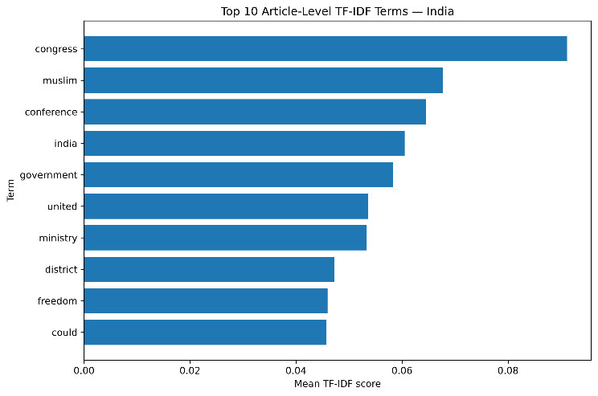
Fig. 1. Top TF-IDF terms for India.
Figure 2 illustrates the top TF-IDF terms for British Malaya.
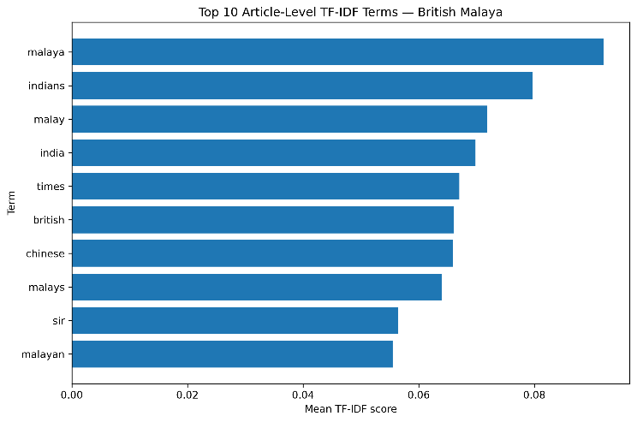
Fig. 2. Top TF-IDF terms for British Malaya.
Figure 3 illustrates the top TF-IDF terms for Australia.
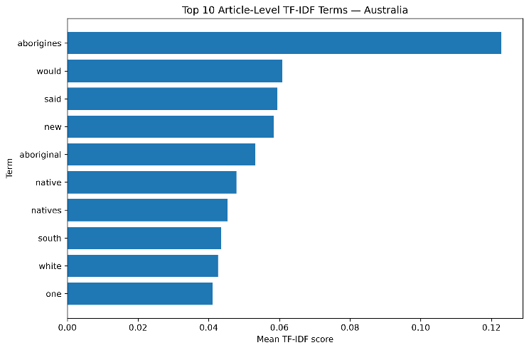
Fig. 3. Top TF-IDF terms for Australia.

Contextual Patterns
To examine how important terms were used within their surrounding context, collocation and concordance analysis was applied to selected words across the three corpora. This provided additional context for the frequency and TF-IDF results and helped identify the issues that were commonly associated with particular terms.
The term “government” showed different patterns across the three contexts. In the Indian articles, it commonly occurred alongside terms such as “Congress,” “backward,” “areas,” “responsibility,” “district,” and “freedom.” These associations were largely connected to government responsibility, political organisation, and the administration or reform of particular groups and regions. In the British Malayan articles, “government” was frequently associated with “Indian,” “Malay,” “labour,” “peasants,” “Malaya,” “education,” “health,” and “estate.” This placed government discussion more closely alongside labour, agricultural communities, ethnic groups, and social policy. In the Australian articles, the term was commonly associated with “missions,” “control,” “subsidies,” “administration,” “Queensland,” “territory,” and “natives.” These associations indicate a stronger connection between government and the direct administration of Aboriginal affairs within the sampled Australian articles.
Concordance analysis provided further insight into the use of the term “native” in the Australian corpus. The term appeared in several different contexts, including descriptions of Aboriginal identity, government institutions, reserves, movement, and relationships with land. References included the Native Affairs Department, native stations and compounds, Native Courts, and government officers responsible for Aboriginal administration. The term was also used in descriptions of Aboriginal ways of life and relationships with the environment. This shows that “native” was not used in a single context, but frequently occurred alongside both administrative and ethnographic descriptions.
The concordance analysis of “people” also showed differences between the three contexts. In the Indian articles, the term was used in references to groups such as Hill Tribes and Indian people, as well as broader discussions of political identity and humanity. In British Malaya, “people” was commonly used in discussions of different communities and cultural groups, including references to Malayan and indigenous populations. In the Australian articles, the term frequently occurred in discussions contrasting Aboriginal and white populations and in descriptions of Aboriginal communities. These patterns demonstrate that the same general term could perform different discursive functions depending on the historical context in which it appeared.
Overall, the contextual analysis supports the broader lexical patterns identified through frequency and TF-IDF analysis. The results suggest that government-related language in the Indian sample was more closely connected with political and reform-oriented discussions, while the British Malayan sample associated government with labour, ethnic communities, and agricultural policy. In Australia, government-related language was more closely connected with Aboriginal administration, control, and institutional structures. These findings provide a basis for the broader interpretation of colonial and settler-colonial discourse presented in the Discussion section.

Discussion
The results indicate that newspaper discourse in the three sampled contexts differed in the issues and forms of representation that were most prominent. Although the three corpora were all published in 1939 and were connected to the wider British imperial environment, their vocabulary and contextual patterns reflected different political and social circumstances. The Indian corpus was characterised by political and institutional language, the British Malayan corpus by discussion of ethnic communities, labour, and colonial policy, and the Australian corpus by language concerning Aboriginal identity, government administration, and racial boundaries.
In the Indian corpus, the prominence of terms such as “Congress,” “government,” “freedom,” “ministry,” “resolution,” and “conference” points to the importance of political organisation and questions of government and reform within the sampled articles. References to tribes, peasants, labourers, and religious communities also show that political discussion was connected to social and economic issues. The appearance of terms such as “Muslim” among the highest TF-IDF terms further indicates that religious identity formed part of the discourse in some of the selected articles. However, the absence of terms such as “Hindu” from the highest-ranked TF-IDF terms should not be interpreted as evidence that Hindu identity was historically unimportant or absent. TF-IDF reflects the vocabulary of the selected articles rather than the demographic or cultural composition of India as a whole.
The British Malayan results show a different pattern. Terms including “Malay,” “Malaya,” “Indians,” “Chinese,” “British,” “labour,” and “policy” indicate that relations between different ethnic and social communities were an important part of the sampled discourse. The collocation analysis further showed that “government” frequently occurred alongside terms relating to Indian and Malay labour, peasants, estates, education, and health. This suggests that colonial government was often discussed in relation to economic production and the management of different communities. The presence of terms such as “padi,” “rice,” “lands,” and “production” also reflects the importance of agricultural and land-related questions within the selected British Malayan articles.
The Australian corpus displayed a particularly strong concentration of vocabulary relating to Aboriginal people and their administration. Terms such as “aborigines,” “native,” “aboriginal,” “white,” “reserves,” “territory,” and “police” were prominent in the frequency and TF-IDF analyses. The contextual analysis of “government” showed associations with missions, control, administration, subsidies, and Aboriginal affairs. Similarly, the concordance analysis of “native” showed that the term appeared in discussions of government departments, courts, reserves, movement, and Aboriginal ways of life. This suggests that representations of Aboriginal people in the sampled Australian articles were frequently connected to institutional administration and relationships of control, while cultural and ethnographic descriptions also formed part of the discourse.
A common pattern across the three contexts was the close relationship between representations of people and government. However, the nature of this relationship differed. In the Indian sample, government language was more closely connected to political authority, reform, and questions of freedom. In British Malaya, it was associated with labour, ethnic communities, agriculture, and social policy. In Australia, it was more strongly associated with the direct administration and regulation of Aboriginal people. This difference is important because it shows that colonial and settler-colonial discourse did not operate through one uniform vocabulary. Similar concepts such as government, people, and policy were used within different political and social circumstances.
The results also demonstrate the value of combining quantitative and contextual NLP methods. Frequency and TF-IDF identified broad differences in the vocabulary of the three corpora, but concordance and collocation analysis provided additional information about how those terms functioned within individual articles. This was particularly important for historically sensitive terms such as “native” and “people,” whose meaning and function depended heavily on context. The combination of these methods therefore provided a more useful basis for interpreting the newspaper material than frequency measures alone.

Limitations
This study has several limitations that should be considered when interpreting the results. First, the corpus is relatively small, containing 36 articles across the three contexts. The articles were selected purposively based on their relevance to the research question rather than through random sampling. As a result, the findings describe patterns within the selected articles and cannot be treated as representative of all newspaper coverage in India, British Malaya, or Australia in 1939.
The number of articles also differs between the three contexts. Australia contains 17 articles, compared with 10 from British Malaya and 9 from India. There are also differences in article length, with the British Malayan articles containing more clean tokens on average than the Australian articles. These differences mean that direct comparisons of raw frequencies would be misleading, which is why normalised frequencies were used where appropriate.
The thematic distribution is another limitation. People is strongly represented across all three corpora, while some categories contain only a small number of articles. In particular, the Indian Land category contains only one article and the British Malayan Culture category contains one article. These small categories are useful for identifying examples and patterns for further investigation, but they do not provide enough evidence for strong quantitative conclusions about those themes.
A further limitation comes from the quality of historical newspaper OCR. Although preprocessing removed obvious formatting and OCR artefacts, some errors may remain in the texts. A conservative cleaning approach was deliberately used to avoid changing historical wording, meaning that not every OCR error was corrected. This may have affected word frequencies and TF-IDF scores, particularly for less frequent terms.
Finally, NLP measures such as word frequency and TF-IDF capture patterns in vocabulary but do not by themselves determine the meaning or historical significance of a text. Historical terms can have meanings that depend heavily on their context, and the terminology used in the newspapers may also reflect racial and colonial assumptions of the period. For this reason, collocation and concordance analysis, together with manual reading of the articles, were used to provide contextual interpretation. The results should therefore be understood as a combination of computational patterns and qualitative historical analysis rather than as purely quantitative measurements of colonial discourse.

Conclusion
This study examined English-language newspaper discourse in India, British Malaya, and Australia during 1939 using a combination of NLP techniques and manual thematic analysis. The analysis focused on the representation of People, Land, and Culture within a corpus of 36 selected newspaper articles. Although the three contexts were connected through the wider British imperial environment, the results showed differences in the vocabulary and issues that were most prominent within the sampled articles.
The Indian articles were more strongly associated with political and institutional language, including terms related to Congress, government, freedom, conferences, and social groups. The British Malayan articles showed a stronger focus on ethnic and community identities, labour, agriculture, and colonial policy, with Malay, Indian, Chinese, and British identities appearing frequently. The Australian articles were particularly concentrated on Aboriginal people, racial classification, reserves, government administration, and cultural practices. Collocation and concordance analysis further showed that terms such as “government” and “native” were used in different contexts across the corpora, demonstrating the importance of examining words within their surrounding historical context.
Overall, the findings suggest that NLP can provide a useful way of identifying patterns in historical newspaper discourse when combined with manual interpretation. Rather than showing a single form of colonial discourse, the results indicate that representations of people, land, and culture varied according to the political and social circumstances of each context. At the same time, the small and purposively selected corpus means that the findings should be treated as exploratory. Future work could extend the corpus across more newspapers and years, improve OCR correction, and apply additional methods such as topic modelling, sentiment analysis, or semantic change analysis to examine how these patterns developed over time.

References
- Australian Institute of Aboriginal and Torres Strait Islander Studies (AIATSIS), Aboriginals Preservation and Protection Act 1939, Queensland, 1939.
- Australian Institute of Aboriginal and Torres Strait Islander Studies (AIATSIS), “Missions, stations and reserves,” AIATSIS.
- S. Chander, “Congress—Raj Conflict and the Rise of the Muslim League in the Ministry Period, 1937–39,” Modern Asian Studies, vol. 21, no. 2, pp. 303–328, 1987.
- C. Newbury, “Malaya,” in Patrons, Clients, and Empire: Chieftaincy and Over-rule in Asia, Africa, and the Pacific, Oxford University Press, 2003, pp. 149–176.
- S. Sundara Raja and S. Raymond, “The lost race in British Malaya: revisiting the problems of south Indian labourers,” Diaspora Studies, vol. 11, no. 2, 2018, pp. 115–134.
- C. W. Booth, A. Thomas, and R. Gaizauskas, “BLN600: A Parallel Corpus of Machine/Human Transcribed Nineteenth Century Newspaper Texts,” in Proc. 2024 Joint Int. Conf. Computational Linguistics, Language Resources and Evaluation (LREC-COLING), pp. 2440–2446, 2024.
- K. Stahel, I. How, L. Millar, L. Paterson, D. Steel, and K. Middendorf, “A Bit of This, a Bit of That: Building a Genre and Topic Annotated Dataset of Historical Newspaper Articles with Soft Labels and Confidence Scores,” Proceedings of the 5th International Conference on Natural Language Processing for Digital Humanities, pp. 377–392, 2025.
- N. Pedrazzini and B. McGillivray, “Machines in the media: semantic change in the lexicon of mechanization in 19th-century British newspapers,” Proceedings of the 2nd International Workshop on Natural Language Processing for Digital Humanities, pp. 85–95, 2022.
- F. Dobranić, B. Evkoski, and N. Ljubešić, “A Lightweight Approach to a Giga-Corpus of Historical Periodicals: The Story of a Slovenian Historical Newspaper Collection,” Proceedings of LREC-COLING 2024, pp. 695–703, 2024.
- S. Bird, E. Klein, and E. Loper, Natural Language Processing with Python, O'Reilly Media, 2009.
- F. Pedregosa et al., “Scikit-learn: Machine Learning in Python,” Journal of Machine Learning Research, vol. 12, pp. 2825–2830, 2011.

